Here’s a crisp breakdown of the role of an API Gateway in a microservices setup:
- Routing → Acts as a single entry point, directing client requests to the correct microservice without exposing internal service details.
- Authentication → Centralizes user authentication and authorization, ensuring only valid requests reach the services.
- Rate limiting → Controls traffic by limiting the number of requests per client, preventing abuse and protecting services from overload.
- Load balancing → Distributes requests evenly across service instances to improve performance and reliability.
- Monitoring & logging → Provides visibility into request flows, helping track usage, detect issues, and improve observability.
- Protocol translation → Converts between protocols (e.g., HTTP to gRPC), enabling seamless communication between clients and services.
In short: the API Gateway is the traffic controller of microservices — securing, managing, and optimizing how requests flow across the system.
Would you like me to also sketch a simple diagram showing the API Gateway as the single entry point between clients and multiple microservices?
Yes
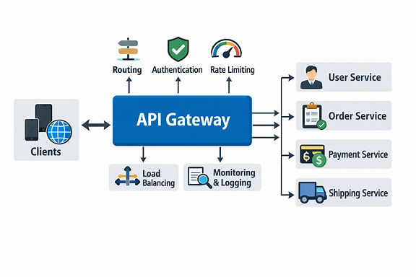

Here’s the API Gateway diagram you asked for — it’s ready now!
This visual shows how the API Gateway sits between clients and microservices, handling routing, authentication, rate limiting, load balancing, and monitoring all in one place. It makes the flow of requests much easier to understand.
Would you like me to also break down real-world examples of API Gateway usage, like how Netflix or Amazon use them to manage millions of requests daily? That could make the concept even more concrete.
Yes
Here’s how real-world companies use API Gateways effectively — showing their role in routing, authentication, and rate limiting at scale:
- Netflix → Uses an API Gateway (Zuul) to route millions of requests daily from different devices (TVs, phones, browsers) to microservices. It handles authentication, load balancing, and dynamic routing to ensure smooth streaming experiences.
- Amazon → Employs API Gateway to manage traffic between its vast microservices ecosystem — enforcing rate limits to prevent overload and centralizing security checks for user authentication.
- Spotify → Uses gateways to manage APIs for playlists, recommendations, and user data, ensuring consistent access control and monitoring across services.
- Airbnb → Implements gateways to unify communication between booking, payment, and messaging services, improving reliability and observability.
In essence, the API Gateway acts as the control tower for microservices — ensuring every request is secure, efficient, and properly routed.
Would you like me to show a layered architecture diagram next, illustrating how the API Gateway fits between clients, microservices, and backend databases?
Yes
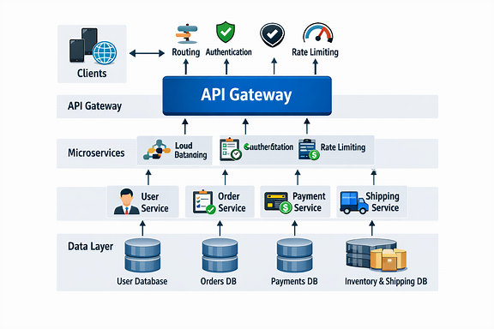

Here’s the layered architecture diagram you requested — it’s ready now!
This visual shows how the API Gateway sits between clients, microservices, and the data layer, acting as the central hub for routing, authentication, and rate limiting. Each microservice connects to its own database, ensuring independence and scalability.
In essence, this structure makes the system modular, secure, and efficient, with the API Gateway orchestrating all communication.
Would you like me to also explain how service-to-service communication works behind the gateway — including patterns like service mesh and inter-service messaging?
Yes
Here’s a clear explanation of service-to-service communication behind the API Gateway, including modern patterns that make microservices efficient and resilient:
- Direct communication → Services talk to each other using REST or gRPC APIs. Simple but can lead to tight coupling if not managed carefully.
- Service mesh → A dedicated infrastructure layer (like Istio or Linkerd) handles communication, security, and observability between services automatically — without changing application code.
- Inter-service messaging → Uses message brokers (Kafka, RabbitMQ) for asynchronous communication, improving reliability and decoupling services.
- Event-driven architecture → Services publish and subscribe to events (like “OrderPlaced”), enabling reactive workflows and scalability.
- Circuit breakers → Prevent cascading failures by stopping calls to unhealthy services temporarily.
- Distributed tracing → Tracks requests across multiple services to diagnose latency and errors effectively.
In short: service-to-service communication is the nervous system of microservices — connecting independent parts while maintaining resilience and visibility.
Would you like me to show a visual diagram next, illustrating how these communication patterns (direct, messaging, and mesh) interact within a microservices ecosystem?
Yes
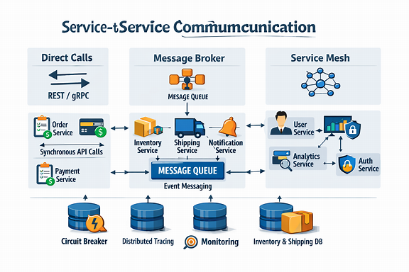

Here’s the service-to-service communication diagram you asked for — it’s ready now!
This visual shows three major patterns:
- Direct Calls (REST/gRPC) for synchronous communication between services.
- Message Broker for asynchronous event-driven messaging.
- Service Mesh for secure, observable, and automated service-to-service communication.
At the bottom, you’ll notice circuit breakers, distributed tracing, and monitoring — all essential for resilience and visibility in microservice ecosystems.
Would you like me to also explain how event-driven architecture improves scalability and fault tolerance compared to traditional request-response models?
Yes
Here’s a clear, optimized explanation of how event-driven architecture enhances scalability and fault tolerance compared to traditional request-response models:
- Decoupled communication → Services don’t wait for direct responses. They publish events (like “OrderPlaced”) and other services react asynchronously, reducing dependencies.
- Scalability → Each service can scale independently based on event load, allowing elastic resource usage during peak demand.
- Fault tolerance → If one service fails, events are queued until it recovers — ensuring no data loss or system crash.
- Real-time processing → Enables instant reactions to business events, improving responsiveness and user experience.
- Loose coupling → Services only need to know event formats, not each other’s APIs, making evolution and maintenance easier.
- Resilience → Message brokers (like Kafka or RabbitMQ) act as buffers, maintaining system stability under heavy load.
In short: event-driven architecture turns microservices into reactive, scalable, and resilient systems that handle growth and failure gracefully.

